Project 2

Suppose an application for an opinion poll is to be built. Assume that only one issue is being polled. Respondents may choose yes, no, or don’t care. A server process accepts the votes, keeps the tally in global variables (yesCount, noCount, dontCareCount), and provides the current counts to those who are interested. A client process runs on the client side. The polling is to take place on a university campus during a time period of 30 minutes, allowing thousands of students to cast their votes from hundreds of workstations.

Following is a sample sequence diagram proposed for the application:

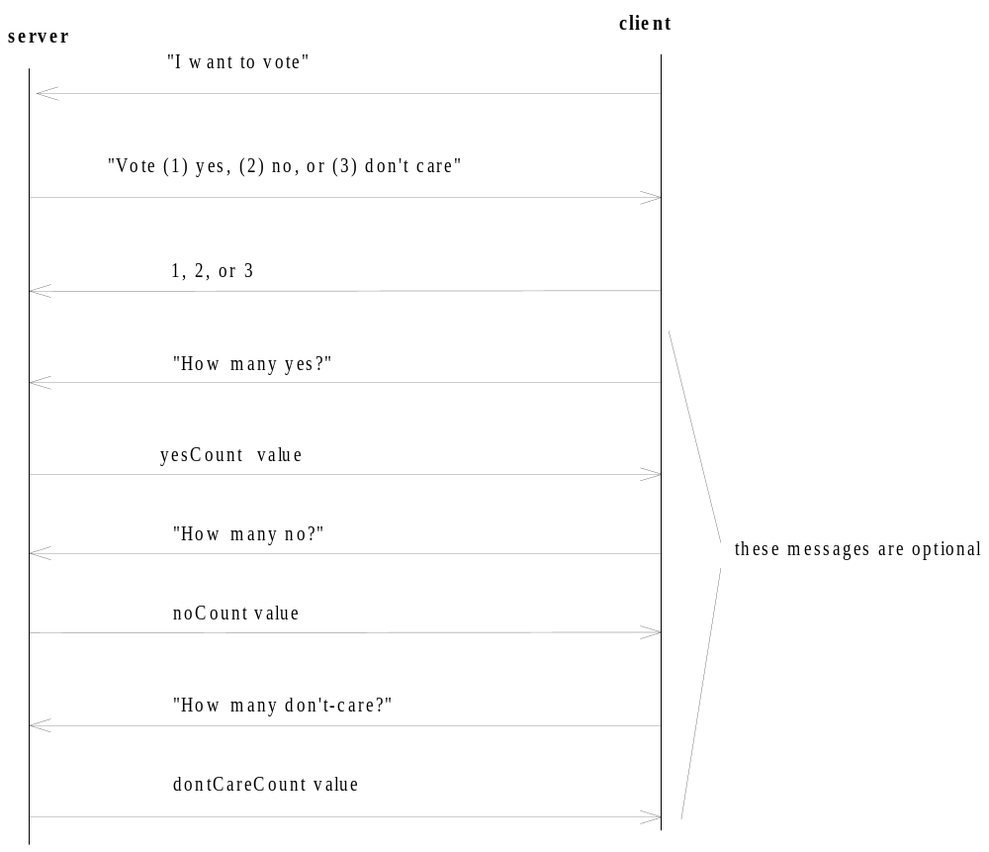

- You can use the above sequence diagram to implement the system. Or you can design a new reasonable protocol for the client and server to comunication. Use RMI.
  - Refer to the Hello example in RMI chapter.
  - Try to compare it with the message passing implementation in Project 1.
  - There could be three methods in the remote object, a welcome (to show the three options), a vote, and a checkStatus (return current vote status). You can have your own design.
- (Bonus questions, 20 points)
  - Implement a callback function. When YesCount reaches a certain number, notify all clients who registered for callback previously.
  - Implement a graphic user interface at the client side.
  - Any additional reasonable feature you may want to add to the design.
Note:
This will be a group project. Up to 2 students in each group. Only one submission is needed from each group.
Other than source code of all needed programs for the excecution, a document is needed including (1) team members and each one’s contribution to the project; (2) your design including the sequence diagram, detailed functions of your application, and testing report.

